1. 20 points] Where on the EKG waveform would you expect to see an indication of atrial repolarization? Briefly explain.

EKG waveform consists of P, QRS, and T waves. The P wave is related to atrial depolarization. The QRS complex is identified with ventricular depolarization. The atria repolarization follows in time its depolarization and happens during the QRS complex. The ventricle is much bigger than the atrium (the ventricle has a mass and wall thickness up to five times that of the atrium), the QRS complex has a much larger amplitude compared to the P and T waves, and it masks the atria repolarization which does not show up on the EKG tracing.

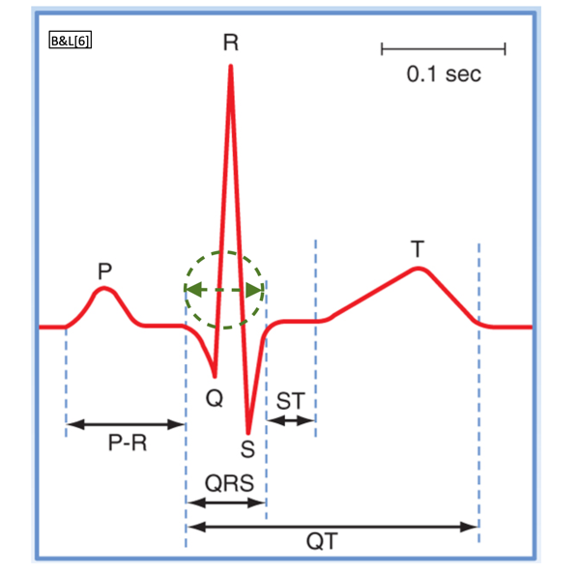

**Fig. 1**: EKG waveform with in dashed green circle and green arrow

where the atrial repolarization happens but is hidden by the QRS complex.

1. [20 points] What would be the effect on the cardiac fast action potential of an increase (as compared to its normal value – see, e.g., video 3, slide 5) in gIK1 at values of membrane voltage between approximately -10 to +10 mV? Briefly explain

An increase of gIK1 at values of membrane voltage between approximately -10 to +10 mV increases the efflux of potassium during late phase 2 and early repolarization phase 3. Phase 2 becomes slightly shorter and possibly has a steeper negative slope. If the increase of gIK1, is significant the transition between phase 2 and phase 3 is less and less visible and phase 2 becomes non-existent.

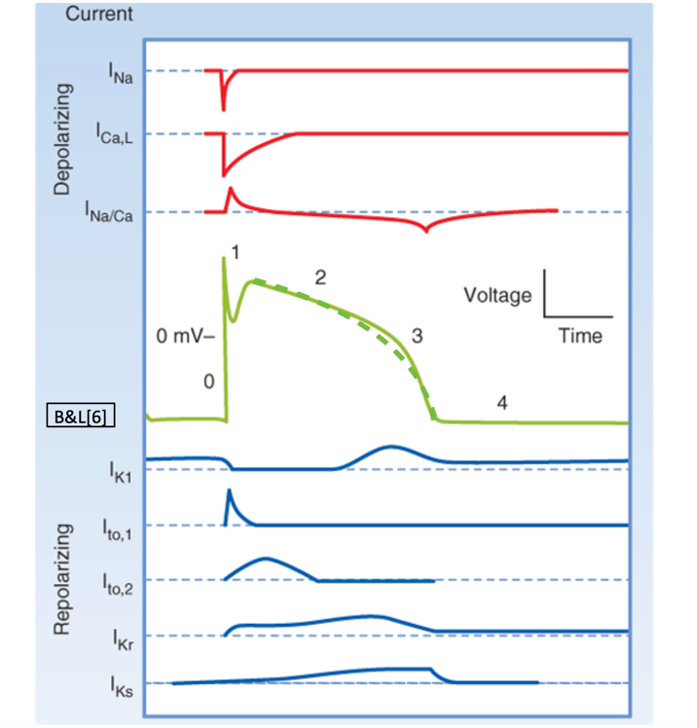

**Fig.2**: in dashed green, phase2 of the cardiac fast action potential changes in duration and slope due to an increase in gIK1 at values of membrane voltage between approximately -10 to +10 mV.

1. [20 points] Describe/discuss/explain the mechanism(s) that cause conduction velocity within the AV node to be lower than in other myocardial tissue.

An important role of the AV node is to conduct the action potential from the atrium to its respective ventricle. And an important aspect of this conduction is to introduce a delay between atrial and ventricular excitation to give time for the atrium to contract and empty its blood into the respective ventricle before the ventricle begins to contract.

The largest delay is through the AV node and is about 90ms. The second delay, which is about 40ms, happens after the AV node through the penetrating portion of the A-V bundle, then through the distal portion of the A-V bundle up to the separation into left and right bundle branches. In total the delay from arrival of the action potential at the AV node to its arrival at the left and right bundle branches is about 130ms (see fig.3 from video 5, slide 2).

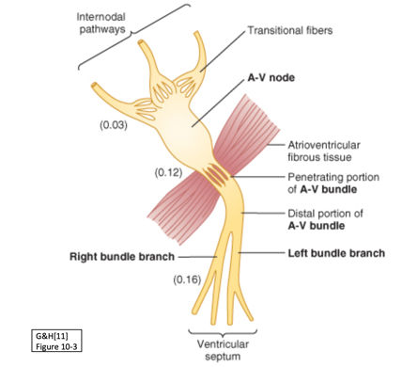

**Fig. 3**: conduction velocity delay within the AV node

Research has shown that the delay is the result of many factors including the complex arrangements of the nodal myocytes, poor electrical coupling between the myocytes of the AV nodes and multiple other factors.

1. [20 points] What would be the effect(s) on the cardiac pacemaker action potential of a partial blockage of the “funny” Na current? Briefly explain.

The initial gradual depolarization to threshold is due to the inward Na+ current, and a partial blockage of this “funny” sodium current slows down the rate of depolarization, the cardiac pacemaker membrane potential rises even more slowly up to threshold (slope is reduced). As the time to reach the threshold increases, there is more time between action potentials, lowering the heart rate.

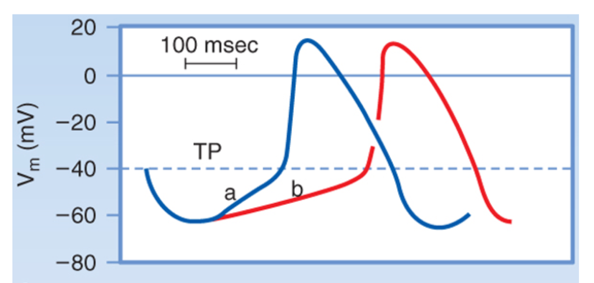

**Fig. 4**: For the same threshold potential (TP), a decrease of the “funny” inward current from [a] to [b] reduces the slope of the pacemaker action potential, resulting in slower depolarization during phase 4 (video 4, slide 5).

1. [20 points] What would be the effect of an increased conduction velocity through the AV node on the EKG waveform? Briefly explain.

In the EKG waveform, the P wave is related to the spread of depolarization through the atria, the QRS complex is associated with the depolarization of the ventricles.

The zero-voltage period after the P wave represents the time in which the cardiac impulse is traveling through the AV and the bundle of His node (and where the conduction velocity is lower due to a delay in conduction of the impulses). When the conduction velocity through the AV node is increased, this zero-voltage period (PR segment in fig. 5) is shorter in time. As a result of the PR segment being shorter, the PR interval which measures the time from the onset of atrial activation to the onset of ventricular activation is also shorter. The heart rate is increased.

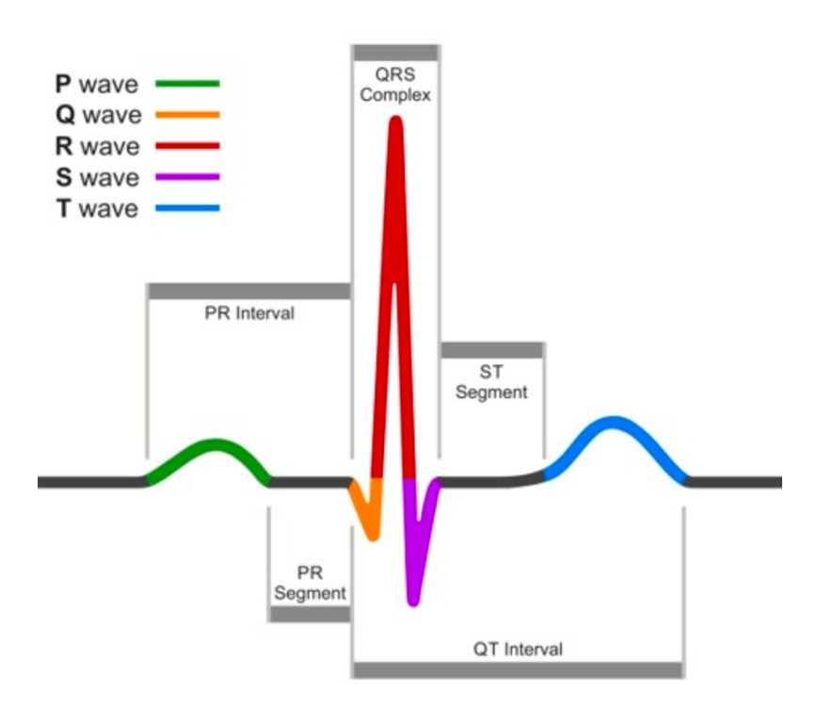

**Fig. 5**: EKG waveform reference: [EKG.MD](https://ekg.md/content/pr-segment-basics/)